
Alstonville RSL Sub-Branch

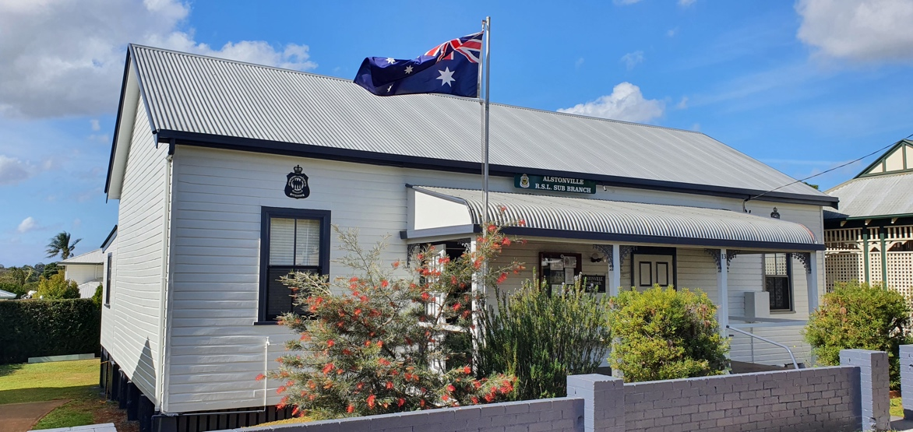
  Standfat 2026
    - Issue 300
    - July 2026
FOR YOUR DIARY:
Next Sub-Branch meeting Saturday 8th August 2026
@ 10;30am
13 Budgen Avenue
Alstonville NSW 2477
Email: AlstonvilleSB@rslnsw.org.au
www.alstonvillerslsubbranch.org.au
PHONE/FAX 02 6628 6156
PO Box 692 ALSTONVILLE NSW 2477
Alstonville RSL Sub-Branch Office Bearers
President | John Porter | 0477773140 | All emails to:
Vice President | Phil Skinner | 0427291292 | AlstonvilleSB@rslnsw.org.au  jonportrsl@gmail.com
Vice President | Steve Bryce | 0427202384
Secretary  Treasurer | John Porter  Gary Henderson - Smith | 0400474413



Dear Members
This month has seen lots of us unwell. I’m terribly sorry if I was the carrier. LOL
On the 15 August at EAB Memorial, we commemorated the Korean War Day. We had very few numbers turnup, but the thought was there.
At our last meeting, John Gordon resigned as the Honorary Secretary of our Sub-Branch, after nearly 6 years, this time. Please join with me in thanking John for his tireless service and dedication.
Thanks to the workers who pruned the trees at the front of the hall. It now looks much cleaner. A further update on the portico, it will be completed in two weeks. The holdup is due to the tradies being behind due to inclement weather. We have all the trades covered, including the painter. Fingers crossed!!
I would like all members to start thinking about our lunch arrangements for our monthly meetings. Rob Wilson will no longer act as our personal chef. He is a valued member of our Sub-Branch and will be involved in our committee moving forward. What is easy and best for future lunches? Ideas please.
The committee is working on having an exhaust fan fitted to our kitchen. Furthermore, we need to upgrade our office printer. Quotes are being obtained from suppliers.
Well–Being
Well-being is the state of feeling healthy, happy, and safe. It means your body, mind, and feelings are in a good and stable place.
Key Parts of Well-being
- Physical: Having a healthy body, eating good food, and resting well.
- Mental: Managing stress, thinking clearly, and feeling calm.
- Emotional: Feeling joy, love, and knowing how to handle sad or hard times.
- Social: Having good friends, family, and a safe place in your community.

If you are feeling lost or lonely and in need of a coffee, ring me on 0477773140

From the President

MINUTES of the sub-Branch General Meeting dated 13 June 2026
Chairman: John Porter, declared the meeting open at 11:03am with the wreath laid by VP Phil Skinner followed by the Ode and a half minutes silence.
Attendance was 22 with 7 apologies
MOTION – Those apologies be accepted
Moved – Steve Bryce Second – Phil Skinner
CARRIED
Minutes of the Meeting held on 13 June 2026
MOTION - That the Minutes of the meeting on 13 June 2026, as printed, be accepted as a true record of that meeting.
Moved - Secretary Seconded – Rob Wilson CARRIED
Business arising from minutes – Nil business arising

Correspondence
Inwards
Secretary read the received and sent correspondence including:
State circulars
MOTION – That the inwards correspondence be adopted, and the Outwards correspondence be endorsed.
Moved – John Gordon Seconded – Alan Brown CARRIED

Treasurers Report
The Secretary presented the Revenue statements and accounts as at 30 May 2026 and the Accounts for payment.

MOTION – That the Revenue Statement as at 30 May 2026 be accepted, and the Payment of Accounts for June/July be approved.

Moved – John Gordon Seconded – Gary Henderson-Smith CARRIED

State HQ – Nothing to report
FNCDC – The FNCDC Meeting 24 May 2026
Welfare & Hospital visits – Last week we had 13 patients to visit
Hall Bookings- No changes
Membership – Membership is now 75
Memorabilia- No change
Fundraising – VSF refunded yearly insurance premium

General Business
Front garden working bee names. Start after meeting Grahame Gooding Supervising
Quotation for shipping container storage. Members vote next meeting
Voluteers for Sub-Branch open days. Tuesdays and Fridays (Visitors Log Book)
Working party to mount portico. Date TBA
Veteran & Family Sunday afternoon BBQ games and movies. Combined with Astronomy Club on the 16 August 2026.
Involving the community ie fishing club, bowls, book clubs. Etc
Holding Events – Rally drive, Lego display other.
Commemorative days for remainder of year- Korean Veterans Day, 27th Jul 2026 - Yes
Victory in Pacific, 15 August 2026- No
Vietnam Veterans Day, 18 August 2026- Yes
Malay/Borneo Day, 31 August 2026- No
Australia Day, 2 September 2026- Yes Dinner
Merchant Navy Day, 3 September 2026- No
National Peacekeepers Day, 14 September
2026- Yes
Remembrance Day 11 November 2026- Yes
Re-Election of Gary Henderson-Smith as Treasurer.
Resignation of Secretary – John Gordon accepted by President & Members.

Sub-Branch Meeting Minutes

This monthly Standfast report is under review. We are seeking guidance from you as to what needs to be in it.

Do you entirely read it?

Do you read parts of it?

Is there something that needs to be incorporated into it?






